

Q1 2025
KAMLOOPS & DISTRICT
MARKET OVERVIEW
April 2025
01
50
100
150
200
250
300
350
400
450
Jan
Feb
Mar
Apr
May
Jun
Jul
Aug
Sep
Oct
Nov
Dec
Year range
10
10
year average
2025
2024
$0.0
$0.5
$1.0
$1.5
$2.0
$2.5
2015
2016
2017
2018
2019
2020
2021
2022
2023
2024
2025
Qtr1
Qtr2
Qtr3
Qtr4
FIGURE 1: RESIDENTIAL SALES VOLUME
KAMLOOPS & DISTRICT
-

$ Billions
FIGURE 2:
NUMBER OF RESIDENTIAL
SALES
KAMLOOPS & DISTRICT
Source: Association of Interior Realtors®, Q1 2025
Source: Association of Interior Realtors®, Q1 2025
FIGURE 3: QUARTERLY RESIDENTIAL QUICK STATS
484 Residential sales in Q1 2025
2.1% increase vs Q1 2024
$284.4 Million transacted in Q1 2025
2.3% increase vs Q1 2024
1,210 New listings in Q1 2025
5.0% increase vs Q1 2024
1,140 Active residential listings as of March 2025
7.2% increase vs March 2024
Residential market activity in Kamloops showed only modest gains in early 2025, following a sluggish 2024 that failed to deliver a traditional spring market. Although early-year buyer interest suggested a stronger start, this did not translate into a notable surge in sales activity. Instead, market performance during the first quarter mirrored the subdued levels seen in the prior year, continuing to lag behind historical transaction levels. In Q1 2025, there were 484 residential sales recorded in the region, valuing $284.4 million. This marks a slight year-over-year improvement of 2.1% in the number of sales and a 2.3% increase in dollar volume. However, total sales remained below the 10-year average, signalling the market’s ongoing challenges.
Early optimism was dampened by a series of external shocks. The most notable being the reintroduction of tariffs under President Trump’s executive orders, which have impacted global markets and introduced significant week-to-week uncertainty. Add in Canada’s upcoming election, and it is no surprise that many would-be buyers
Source: Association of Interior Realtors®, Q1 2025 are hesitant to act. While touring activity has increased consistently with the spring market, many buyers are staying on the sidelines, adopting a wait-and-see approach before committing.
02
0
200
400
600
800
1,000
1,200
1,400
1,600
1,800
1985
1990
1995
2000
2005
2010
2015
2020
2
025
FIGURE 4:
ECONOMIC POLICY
UNCERTAINTY INDEX FOR CANADA
Still, buyers may be quietly gaining an advantage. Interest rates

have declined compared to 2024, and inventory levels have risen, giving purchasers more options and potential negotiating power. While most of the demand continues to come from local buyers, there has been a slight uptick in inquiries from those considering relocation to the Kamloops area. Thanks to its relative affordability and economic resilience, Kamloops is expected to outperform the national economy in the short term.
Alternatively, investor activity has cooled. Recent policy changes, including BC’s vacancy and speculation taxes and concerns over a potential federal capital gains tax, have pushed many investors to the sidelines. This has likely contributed to the growing supply. However, with the recent stock market volatility and real estate viewed by many as a relatively stable alternative, investor sentiment could shift in the months ahead.
Price growth remained stable in Q1, supported by a growing inventory that has prevented significant upward pressure in prices. The composite benchmark price for the region stood at $589,000 in March 2025, representing a modest 0.5% increase over the past 12 months, but still 5.6% below levels seen three years ago.
The market has experienced an increase in both new listings and overall active inventory. In Q1 2025, there were 1,210 new listings, a 5.0% year-over-year rise. This growth has been partially driven by speculative sellers looking to capitalize on demand spurred by falling interest rates—though many remain hesitant to transact—and repeat buyers who, after years of limited inventory, now feel more confident selling their current homes and moving up.
Source: Federal Reserve Bank of St. Louis, Q1 2025
$0
$100,000
$200,000
$300,000
$400,000
$500,000
$600,000
$700,000
$800,000
2005
2010
2015
2020
2025
Apartment
Single Family
Townhouse
FIGURE 5: HISTORICAL KAMLOOPS
BENCHMARK PRICE
Source: Association of Interior Realtors®, Q1 2025

FIGURE 6: KAMLOOPS EMPLOYMENT
GROWTH – Year-Over-Year (000s)
25
-20
-15
-10
-5
0
5
10
15
20
2020
2021
2022
2023
2024
2025
Source: Statistics Canada, Q1 2025

03
FIGURE 7: COMMUNITY WORKFORCE EXPOSURE TO U.S. EXPORTS
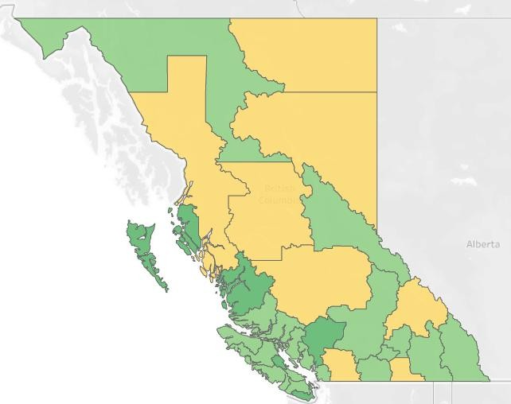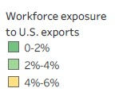
Source: Institute for Research on Public Policy, Q1 2025

Active listings rose to 1,140 by the end of March 2025, a 7.2% increase from the previous year. However, this growth in inventory reflects slower buyer demand rather than a massive surge in new listings. Despite the added supply, the market remains balanced, with the sales-to-new listings ratio hovering around 50% throughout the quarter.
Mortgage rates remain above historic lows, but they have been trending downward over the past 12 months, offering some relief— especially to new home buyers and those renewing in 2025 after buying at the peak during the pandemic. While there is speculation that central banks may cut interest rates to avoid a recession, the Bank of Canada is unlikely to return to the ultra-low rates seen during the pandemic. Cautious after being caught off guard by the post-COVID inflation spike, peaking at 8.1% in June 2022, the Bank is reluctant to act as aggressively. Still, fixed mortgage rates, which are tied to bond yields, remain subject to ongoing global uncertainty and may not decline in the short-term.
From a broader economic perspective, Kamloops appears relatively insulated from the worst potential effects of new U.S. tariffs. According to the Canadian Chamber of Commerce, the region ranks second-lowest among Canadian cities in terms of vulnerability to US tariffs, with exports making up only 2.3% of local GDP and just 15% of those exports going to the U.S. Local economic anchors— including two major mines and Kamloops’ position as a transportation hub—provide further stability. Moreover, Kamloops continues to offer some of the best affordability among major BC cities, a key attractor for both residents and investors. Looking ahead, market conditions in Kamloops suggest the potential for a delayed spring activity increase. Market hesitation may create a backlog of buyers. However, the direction of the market will depend heavily on the broader economic environment and the speed at which confidence returns.

04
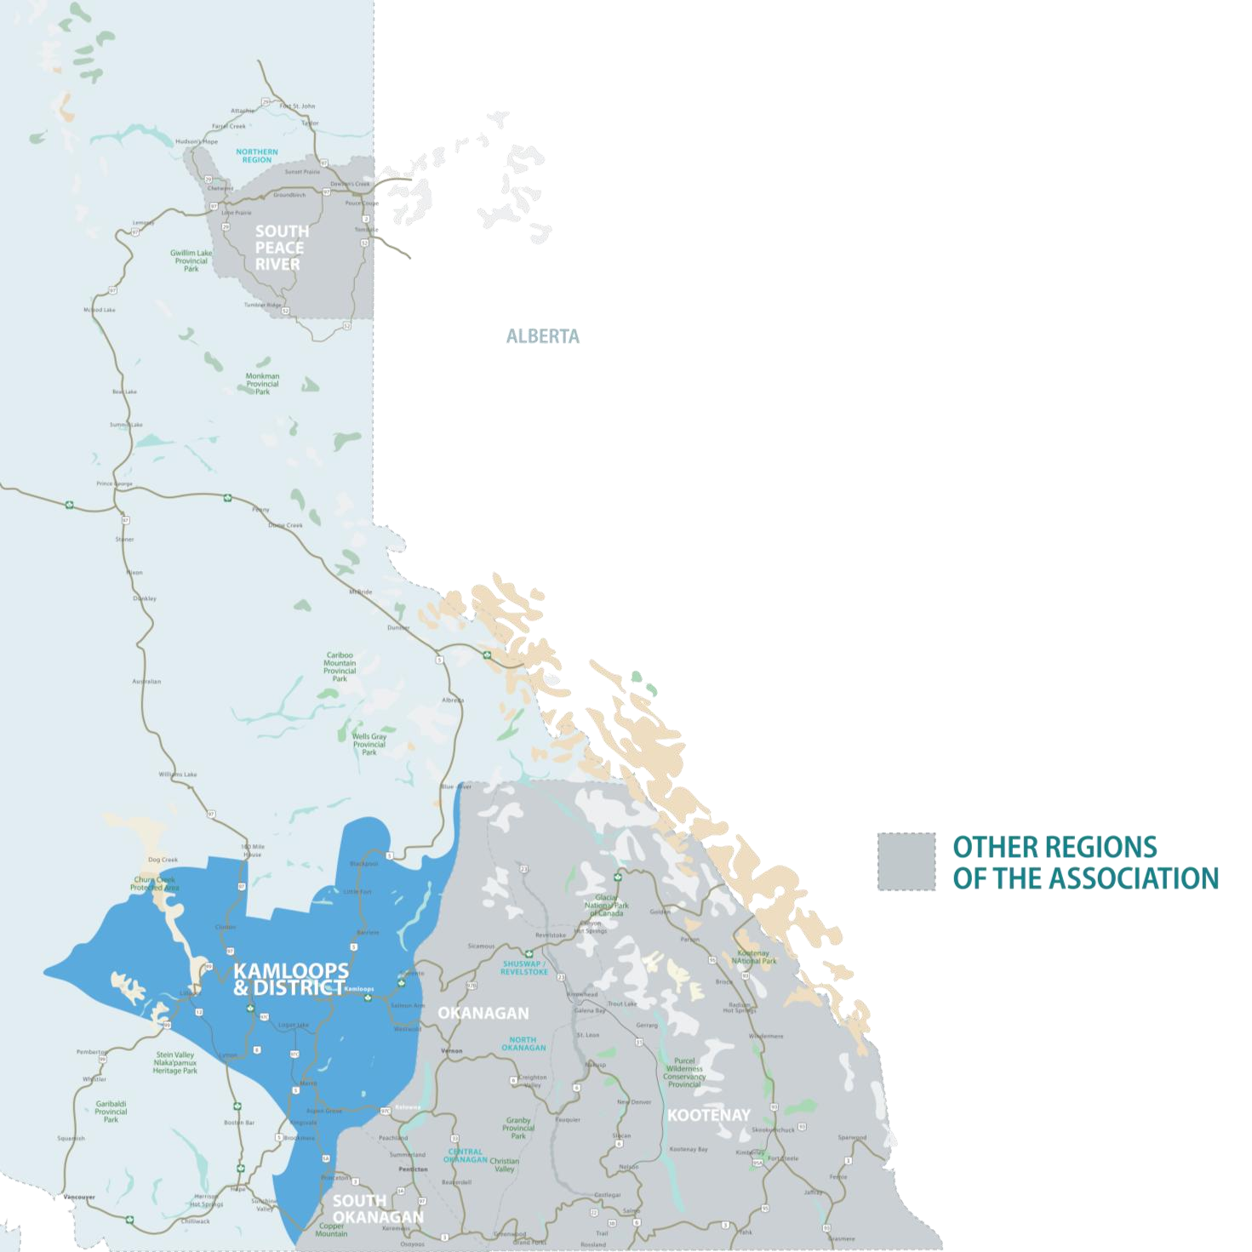
This map is for informational purposes. It does not represent an on-the-ground survey and represents only the approximate relative location of property boundaries.
05
SINGLE
FAMILY*
Sales
205

-
16.7
%
Benchmark Price**
$667,800

0.2
%
Days to Sell
60

5.4
%
KAMLOOPS AND DISTRICT REGION
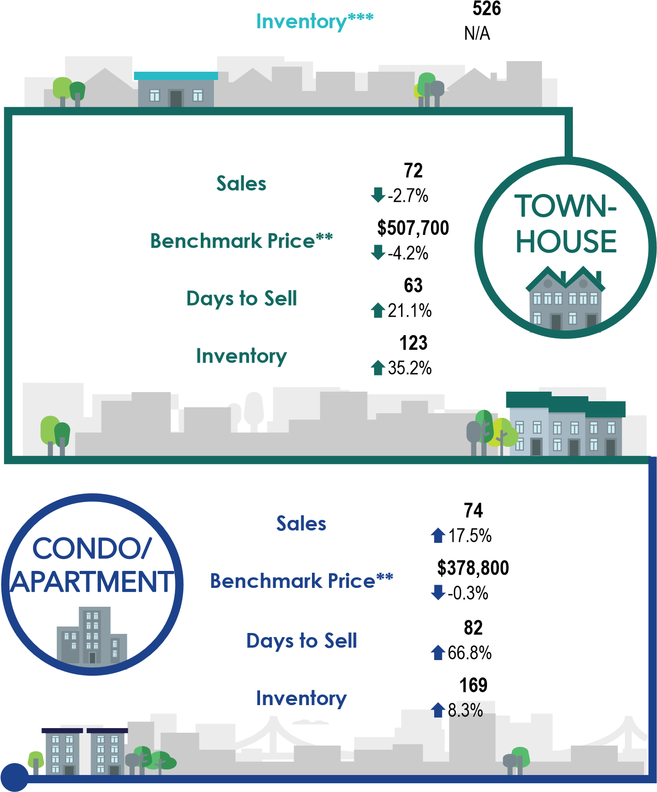
*Excludes lakefront and acreage Single-Family homes, previously included in KADREA’s Single-Family home statistics. ** Benchmark Prices and Inventory as of March 2025.
*** With lakefront and acreage properties included, Single Family home inventory was 675 in March 2025, up 0.9% from March 2024.
**** Percentage represents change compared to the same period last year
06

Q1 2025 Statistics

SINGLE FAMILY* TOWNHOUSE APARTMENT
Location | Benchmark  Sales  Price |  | Sales | Benchmark Price | Sales | Benchmark  Price
Aberdeen | 19  -5.0% | $884,600  2.3% | 9 28.6% | $558,400   -2.2% | 4  -33.3% | $347,800  0.3%
Ashcroft | 2  -60.0% | $374,200  -0.5% | 1  0.0% |  | 3
Barnhartvale | 6  -25.0% | $775,400  2.0% | 0 |  | 0
Barriere | 2  -33.3% | $516,700  -2.7% | 0 |  | 0
Batchelor Heights | 8  -20.0% | $885,500  -1.3% | 2  -33.3% | $549,600   -2.7% | 0
Brocklehurst | 18 20.0% | $645,000  2.3% | 12  300.0% | $385,700   -0.9% | 3 50.0% | $266,200  2.9%
Cache Creek | 0  -100.0% | $430,900  -1.9% | 0 |  | 0
Campbell Creek/Deloro | 3  0.0% | $705,400  3.0% | 1 |  | 0
Chase | 6  100.0% | $511,600  -0.1% | 4 | $495,000   -2.6% | 0
Cherry Creek/Savona | 0 | $855,800  1.4% | 0 |  | 0
Clearwater | 5 25.0% | $469,400  -3.3% | 0 |  | 1
Clinton | 1  0.0% | $335,000  -0.8% | 0 |  | 0
Dallas | 7  -12.5% | $752,500  1.7% | 0 |  | 3 | $359,000  0.2%
Dufferin/Southgate | 1  -80.0% | $830,600  4.1% | 0 | $684,100   -2.1% | 0 | $443,300  0.0%
Heffley | 1  0.0% | $777,300  0.5% | 0 |  | 0
Lillooet | 7  250.0% | $367,600  -3.8% | 0 |  | 0
Logan Lake | 7  -61.1% | $477,500  -2.1% | 0  -100.0% |  | 5  400.0% | $172,900  4.5%
**Excludes lakefront and acreage Single-Family homes
**Percentage represents change compared to the same period last year *** Benchmark Prices as of March 2025
07

Q1 2025 Statistics

SINGLE FAMILY* TOWNHOUSE APARTMENT
Location | Benchmark  Sales  Price |  | Sales | Benchmark Price | Sales | Benchmark  Price
Merritt | 14  -6.7% | $464,000  -1.6% | 1  -50.0% | $368,700   -3.3% | 1 | $287,500  2.6%
North Kamloops | 19  -17.4% | $549,100  -1.4% | 1 |  | 5 66.7% | $313,800  2.3%
Pinantan | 0  -100.0% | $413,400  -2.0% | 0 |  | 0
Pineview Valley | 1  -80.0% | $796,000  0.9% | 1  -85.7% | $486,600   -3.7% | 3 50.0% | $377,600  0.8%
Pritchard | 0  -100.0% | $485,900  0.2% | 0 |  | 0
Rayleigh | 1  -75.0% | $761,000  3.3% | 0 |  | 0
Sahali | 7 40.0% | $795,400  0.3% | 14  -26.3% | $395,400   -3.2% | 10  -23.1% | $452,000  -1.3%
South Kamloops | 19 5.6% | $688,500  1.2% | 1  -80.0% | $539,100   -4.6% | 15  -11.8% | $353,500  1.3%
South Thompson Valley | 1  0.0% | $839,600  6.4% | 0 |  | 0
Sun Peaks | 1  0.0% | $798,600  -2.2% | 8  0.0% | $846,200   -2.6% | 13 30.0% | $510,500  6.7%
Sun Rivers | 9 12.5% | $916,100  1.7% | 2  0.0% | $671,100   -3.5% | 3  -62.5% | $350,500  1.0%
Valleyview | 5  -28.6% | $820,600  1.8% | 2  0.0% | $566,900   -3.7% | 1  0.0%
Westsyde | 19 5.6% | $749,700  0.5% | 9 28.6% | $414,000   -1.9% | 1 | $401,900  0.6%
Juniper Ridge | 12  -29.4% | $951,300  0.4% | 4  -33.3% | $589,100   -3.3% | 3
**Excludes lakefront and acreage Single-Family homes
**Percentage represents change compared to the same period last year *** Benchmark Prices as of March 2025

CONTACT
ASSOCIATION OF INTERIOR REALTORS®
#112 - 140 Commercial Drive
Kelowna, BC, Canada, V1X 7X6
250-878-0212 media@interiorrealtors.com www.interiorrealtors.com
The Saskatoon & Region Home Builders’ Association is invested in bringing insight to public policy decision makers on matters that effect the residential construction industry, while connecting our members with opportunities.
PREPARED BY


